Cake Ordering System — Backend System Design Document
Version: 1.0
Author: Phindile Sandi
Stack: C# (.NET 8+, Minimal APIs) · PostgreSQL · SPA/Mobile-ready REST API

Table of Contents
- System Architecture Overview
- Customization Toolkit Architecture
- Data Models & Database Schemas
- Process Models & Data Flow Diagrams
- API Surface Summary
- Cross-Cutting Concerns
- Open Decisions / Recommendations for Next Phase

1. System Architecture Overview

1.1 Guiding Principles
- API-first: The backend exposes a versioned REST API (/api/v1/...) designed for consumption by a future SPA and mobile apps. No server-rendered views.
- Modular monolith first, microservices-ready later: Given the scope (catalog, customization, orders, payments, admin), a single well-layered .NET Minimal API service is the right starting point. We structure it internally as vertical feature modules (Catalog, Customization, Orders, Payments, Identity, Admin) so any module can later be extracted into its own service without a rewrite.
- CQRS-lite: Reads (catalog browsing, order history) and writes (order placement, admin edits) are handled through separate service methods/handlers even within the same process, to keep read performance high (catalog is read-heavy) and write logic auditable.
- Event-driven internals: Domain events (OrderPlaced, PaymentConfirmed, OrderStatusChanged) are published internally (in-process mediator, e.g., MediatR-style pattern) and can later be routed to a real message broker (RabbitMQ/Azure Service Bus/Kafka) for the real-time admin dashboard and notifications — without changing calling code.

1.2 High-Level Component Diagram
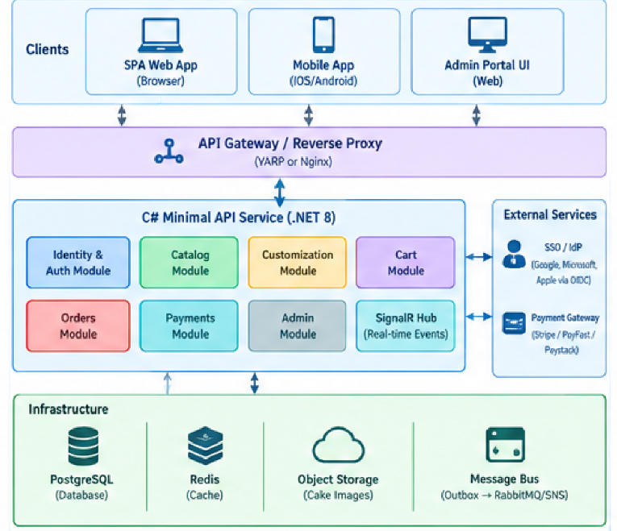

1.3 Technology Choices & Rationale
Concern | Choice | Rationale
API style | .NET 8 Minimal APIs, grouped via MapGroup() per module | Low ceremony, high performance, native OpenAPI support, easy to test
ORM | EF Core with Npgsql provider | First-class Postgres support, migrations, LINQ, change tracking
Auth | ASP.NET Core Identity (admins) + OpenID Connect (customers via SSO) + JWT bearer tokens for API calls | Separates concerns; supports Google/Microsoft/Apple login without storing passwords for customers
Caching | Redis | Cart state, session tokens, catalog read-through cache
Image storage | Object storage (S3-compatible/Azure Blob) with CDN in front | DB should never store binary blobs; only URLs/metadata
Real-time admin updates | SignalR (WebSockets, with fallback) | Native to .NET, integrates cleanly with Minimal APIs, push order updates instantly
Payments | Server-side integration with a PCI-compliant gateway (Stripe / PayFast / Paystack depending on region) using hosted checkout or tokenized cards | We never store raw card data — offload PCI scope to the gateway
Reliability pattern | Transactional Outbox + Idempotency keys | Guarantees "payment confirmed → order updated → admin notified" is not lost even under partial failures
Containerization | Docker + docker-compose for local; Kubernetes/ECS for prod | Standard scalable deployment path

1.4 Layering Within the Service
/src
/Modules
/Catalog (Endpoints, Services, Repositories, DTOs)
/Customization
/Cart
/Orders
/Payments
/Identity
/Admin
/Shared
/Domain (Entities, Value Objects, Domain Events)
/Infrastructure (DbContext, Migrations, ExternalServiceClients)
/Contracts (Shared DTOs/Interfaces between modules)
Program.cs (Composition root — maps all endpoint groups)
Each module owns its own endpoints, request/response DTOs, and business logic, but shares a single PostgreSQL database and AppDbContext initially (modular monolith). Schema-per-module (Postgres schema namespaces: catalog.*, orders.*, identity.*) is used to keep a clean boundary that mirrors a future service split.

2. Customization Toolkit Architecture
This is the most architecturally interesting part of the system. The goal: support a pizza-builder-style experience — a base product with layered, priced, validated modifiers — while remaining generic enough that admins can add new cake types, sizes, flavors, and add-ons without a code deployment.

2.1 Core Design Concept: "Product = Base + Option Groups + Options"
We avoid hardcoding "Size", "Flavor", "Icing" as fixed columns. Instead we model customization as a generic, admin-configurable attribute system, similar to how e-commerce platforms (Shopify variants, food-delivery modifier groups) solve this problem. This is the single most important design decision in the system because it's what makes the Admin Portal's "edit customization options dynamically" requirement possible without redeploying code.
Key entities:
- Cake (Product): The sellable base item (e.g., "Classic Red Velvet"), with a base price and base image.
- CustomizationGroup: A named category of choices belonging to a cake (e.g., "Size", "Flavor", "Icing Type", "Add-ons"). Each group has rules: SelectionType (single-select / multi-select), IsRequired, MinSelections, MaxSelections, and DisplayOrder.
- CustomizationOption: A specific choice within a group (e.g., "8-inch", "Chocolate", "Fondant"), with its own PriceModifier (can be additive, or a multiplier for size-driven repricing), optional ImageOverrideUrl (to visually reflect the choice), and IsAvailable (stock/seasonal toggle).
- CakeCustomizationGroupMap: Join table — which groups apply to which cake (a cupcake might not offer "Tiers", but a wedding cake would). This lets each cake have a different customization schema while reusing the same group/option definitions across the catalog.
- FreeTextField: A special customization type for "Add custom message on cake" — has MaxLength, IsRequired, and optional profanity-filter flag, since this is user-entered text rather than a pre-set option.
- OrderItemCustomization: The snapshot of what the customer actually chose at order time — captured as structured JSON and normalized rows (explained in 2.3) so historical orders remain accurate even if the admin later edits or deletes the live options.

2.2 Why a Hybrid Relational + JSONB Model (not pure EAV, not pure JSON blob)
We evaluated three approaches:
Approach | Problem
Pure rigid columns (size, flavor, icing as fixed columns on Cake) | Cannot scale to new customization types without schema migrations; admin can't add a new group like "Cake Topper" dynamically
Pure JSON blob for the entire product config | Flexible, but impossible to enforce referential integrity, run price validation server-side reliably, report on "most popular flavor", or query efficiently
Pure EAV (Entity-Attribute-Value) | Fully flexible, but notoriously hard to query, index, and validate at scale; performance degrades with joins

Our decision — Hybrid model:
- Structured relational tables (customization_groups, customization_options) define what's possible — this is the admin-editable "menu" of choices, fully normalized, indexable, and constrained by foreign keys and check constraints.
- JSONB column (selected_customizations_json) on order_items stores the actual chosen configuration as a denormalized, human-readable snapshot (option names, prices, text) for fast retrieval/display and to preserve history immutably.
- Normalized junction table (order_item_customization_selections) also stores the same selections as proper foreign-keyed rows, purely for reporting/analytics (e.g., "which flavor sells best this month") and referential price auditing.
This gives us: dynamic admin-driven configuration + fast reads + safe historical snapshots + queryable analytics — the best properties of all three approaches without their individual weaknesses.

2.3 Customization Data Flow (Build → Price → Validate → Persist)
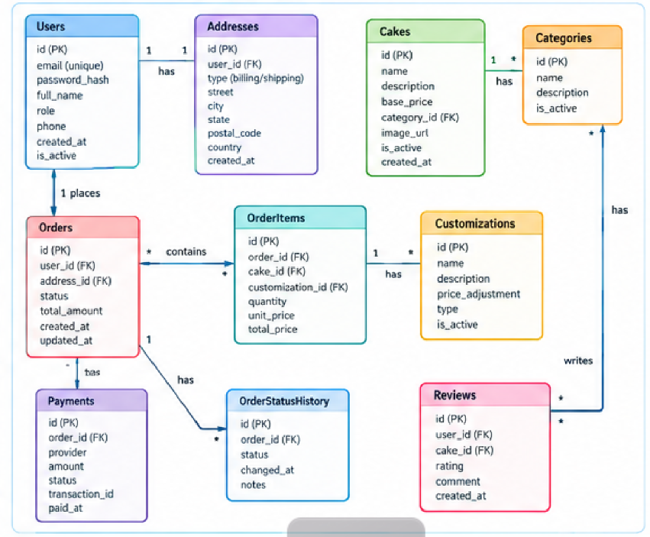
Critical rule: price is always recalculated server-side. The client price shown during customization is a preview only; the server is the single source of truth to prevent price tampering.

2.4 API Shape for the Customization Engine
GET /api/v1/cakes/{cakeId} → Cake detail + applicable groups/options (public)
GET /api/v1/cakes/{cakeId}/customization-schema → Just the groups/options/rules (used by SPA builder to render form)
POST /api/v1/cart/items → { cakeId, selections: [{groupId, optionIds[]}], freeText, quantity }
PUT /api/v1/cart/items/{itemId} → Update an existing customized cart line
POST /api/v1/cart/items/{itemId}/validate → Optional pre-check endpoint before add-to-cart (nice UX)
The customization-schema endpoint returns a self-describing JSON contract, e.g. conceptually:
{
"cakeId": "uuid",
"basePrice": 350.00,
"groups": [
{
"groupId": "uuid",
"name": "Size",
"selectionType": "single",
"isRequired": true,
"options": [
{ "optionId": "uuid", "label": "6-inch (serves 8)", "priceModifier": 0 },
{ "optionId": "uuid", "label": "10-inch (serves 20)", "priceModifier": 250.00 }
]
},
{
"groupId": "uuid",
"name": "Icing",
"selectionType": "single",
"isRequired": true,
"options": [ { "optionId": "uuid", "label": "Buttercream", "priceModifier": 0 },
{ "optionId": "uuid", "label": "Fondant", "priceModifier": 120.00 } ]
},
{
"groupId": "uuid",
"name": "Add-ons",
"selectionType": "multi",
"isRequired": false,
"maxSelections": 5,
"options": [ { "optionId": "uuid", "label": "Fresh Berries", "priceModifier": 45.00 } ]
}
],
"freeTextField": { "label": "Message on cake", "maxLength": 40, "isRequired": false }
}
Because the SPA builder simply renders whatever schema comes back, admins can add a brand-new group (e.g., "Cake Topper Style") purely through the Admin Portal, and it appears in the customer builder immediately — satisfying requirement 5 (dynamic catalog editing) without any backend redeploy.

3. Data Models & Database Schemas
Postgres schemas are namespaced by module: identity, catalog, orders, payments. All primary keys are UUID (generated via gen_random_uuid(), pgcrypto extension) for safe distributed/public exposure. All tables have created_at / updated_at audit columns; soft-delete via is_deleted where historical integrity matters.
-- ============================================================
-- EXTENSIONS
-- ============================================================
CREATE EXTENSION IF NOT EXISTS "pgcrypto";
-- ============================================================
-- SCHEMA: identity
-- ============================================================
CREATE SCHEMA IF NOT EXISTS identity;
CREATE TABLE identity.roles (
role_id UUID PRIMARY KEY DEFAULT gen_random_uuid(),
name VARCHAR(50) UNIQUE NOT NULL -- 'Customer', 'Admin', 'SuperAdmin'
);
CREATE TABLE identity.users (
user_id UUID PRIMARY KEY DEFAULT gen_random_uuid(),
email CITEXT UNIQUE NOT NULL,
full_name VARCHAR(150) NOT NULL,
phone_number VARCHAR(30),
password_hash TEXT, -- NULL for pure-SSO customers
auth_provider VARCHAR(30) NOT NULL DEFAULT 'local', -- 'local','google','microsoft','apple'
external_provider_id TEXT, -- subject/sub claim from IdP
is_super_admin BOOLEAN NOT NULL DEFAULT false,
is_active BOOLEAN NOT NULL DEFAULT true,
email_verified BOOLEAN NOT NULL DEFAULT false,
created_at TIMESTAMPTZ NOT NULL DEFAULT now(),
updated_at TIMESTAMPTZ NOT NULL DEFAULT now()
);
CREATE TABLE identity.user_roles (
user_id UUID NOT NULL REFERENCES identity.users(user_id) ON DELETE CASCADE,
role_id UUID NOT NULL REFERENCES identity.roles(role_id) ON DELETE CASCADE,
PRIMARY KEY (user_id, role_id)
);
CREATE TABLE identity.addresses (
address_id UUID PRIMARY KEY DEFAULT gen_random_uuid(),
user_id UUID NOT NULL REFERENCES identity.users(user_id) ON DELETE CASCADE,
label VARCHAR(50), -- 'Home', 'Work'
line1 VARCHAR(200) NOT NULL,
line2 VARCHAR(200),
city VARCHAR(100) NOT NULL,
province_state VARCHAR(100),
postal_code VARCHAR(20),
country VARCHAR(100) NOT NULL,
is_default BOOLEAN NOT NULL DEFAULT false
);
-- Refresh tokens for JWT rotation
CREATE TABLE identity.refresh_tokens (
token_id UUID PRIMARY KEY DEFAULT gen_random_uuid(),
user_id UUID NOT NULL REFERENCES identity.users(user_id) ON DELETE CASCADE,
token_hash TEXT NOT NULL,
expires_at TIMESTAMPTZ NOT NULL,
revoked_at TIMESTAMPTZ,
created_at TIMESTAMPTZ NOT NULL DEFAULT now()
);
-- ============================================================
-- SCHEMA: catalog
-- ============================================================
CREATE SCHEMA IF NOT EXISTS catalog;
CREATE TABLE catalog.categories (
category_id UUID PRIMARY KEY DEFAULT gen_random_uuid(),
name VARCHAR(100) NOT NULL, -- 'Birthday', 'Wedding', 'Cupcakes'
display_order INT NOT NULL DEFAULT 0,
is_active BOOLEAN NOT NULL DEFAULT true
);
CREATE TABLE catalog.cakes (
cake_id UUID PRIMARY KEY DEFAULT gen_random_uuid(),
category_id UUID REFERENCES catalog.categories(category_id),
name VARCHAR(150) NOT NULL,
description TEXT,
base_price NUMERIC(10,2) NOT NULL CHECK (base_price >= 0),
base_image_url TEXT NOT NULL,
is_active BOOLEAN NOT NULL DEFAULT true,
is_featured BOOLEAN NOT NULL DEFAULT false,
created_at TIMESTAMPTZ NOT NULL DEFAULT now(),
updated_at TIMESTAMPTZ NOT NULL DEFAULT now()
);
CREATE TABLE catalog.cake_images (
image_id UUID PRIMARY KEY DEFAULT gen_random_uuid(),
cake_id UUID NOT NULL REFERENCES catalog.cakes(cake_id) ON DELETE CASCADE,
image_url TEXT NOT NULL,
display_order INT NOT NULL DEFAULT 0
);
-- Admin-configurable customization groups (e.g. Size, Flavor, Icing)
CREATE TABLE catalog.customization_groups (
group_id UUID PRIMARY KEY DEFAULT gen_random_uuid(),
name VARCHAR(100) NOT NULL, -- 'Size', 'Flavor', 'Icing', 'Add-ons'
selection_type VARCHAR(10) NOT NULL CHECK (selection_type IN ('single','multi')),
is_global BOOLEAN NOT NULL DEFAULT false, -- reusable across many cakes
created_at TIMESTAMPTZ NOT NULL DEFAULT now()
);
CREATE TABLE catalog.customization_options (
option_id UUID PRIMARY KEY DEFAULT gen_random_uuid(),
group_id UUID NOT NULL REFERENCES catalog.customization_groups(group_id) ON DELETE CASCADE,
label VARCHAR(150) NOT NULL, -- '8-inch', 'Chocolate', 'Fondant'
price_modifier NUMERIC(10,2) NOT NULL DEFAULT 0,
image_override_url TEXT,
is_available BOOLEAN NOT NULL DEFAULT true,
display_order INT NOT NULL DEFAULT 0
);
-- Which groups apply to which cake, with per-cake override rules
CREATE TABLE catalog.cake_customization_groups (
cake_id UUID NOT NULL REFERENCES catalog.cakes(cake_id) ON DELETE CASCADE,
group_id UUID NOT NULL REFERENCES catalog.customization_groups(group_id) ON DELETE CASCADE,
is_required BOOLEAN NOT NULL DEFAULT true,
min_selections INT NOT NULL DEFAULT 1,
max_selections INT NOT NULL DEFAULT 1,
display_order INT NOT NULL DEFAULT 0,
PRIMARY KEY (cake_id, group_id)
);
-- Free-text customization (e.g. "Happy Birthday Sam!")
CREATE TABLE catalog.cake_text_fields (
field_id UUID PRIMARY KEY DEFAULT gen_random_uuid(),
cake_id UUID NOT NULL REFERENCES catalog.cakes(cake_id) ON DELETE CASCADE,
label VARCHAR(100) NOT NULL DEFAULT 'Message on Cake',
max_length INT NOT NULL DEFAULT 40,
is_required BOOLEAN NOT NULL DEFAULT false
);
-- ============================================================
-- SCHEMA: orders (includes cart, since cart = draft order)
-- ============================================================
CREATE SCHEMA IF NOT EXISTS orders;
CREATE TABLE orders.carts (
cart_id UUID PRIMARY KEY DEFAULT gen_random_uuid(),
user_id UUID REFERENCES identity.users(user_id) ON DELETE CASCADE, -- NULL for guest carts (session-based)
session_token TEXT, -- for guest checkout, stored in Redis + mirrored here
status VARCHAR(20) NOT NULL DEFAULT 'active', -- active, converted, abandoned
created_at TIMESTAMPTZ NOT NULL DEFAULT now(),
updated_at TIMESTAMPTZ NOT NULL DEFAULT now()
);
CREATE TABLE orders.cart_items (
cart_item_id UUID PRIMARY KEY DEFAULT gen_random_uuid(),
cart_id UUID NOT NULL REFERENCES orders.carts(cart_id) ON DELETE CASCADE,
cake_id UUID NOT NULL REFERENCES catalog.cakes(cake_id),
quantity INT NOT NULL CHECK (quantity > 0),
custom_text VARCHAR(200),
unit_price_snapshot NUMERIC(10,2) NOT NULL, -- server-computed, base + modifiers
selected_customizations_json JSONB NOT NULL, -- denormalized snapshot for display
created_at TIMESTAMPTZ NOT NULL DEFAULT now()
);
-- Normalized selections for analytics/reporting & integrity
CREATE TABLE orders.cart_item_customization_selections (
id UUID PRIMARY KEY DEFAULT gen_random_uuid(),
cart_item_id UUID NOT NULL REFERENCES orders.cart_items(cart_item_id) ON DELETE CASCADE,
option_id UUID NOT NULL REFERENCES catalog.customization_options(option_id),
price_modifier_at_selection NUMERIC(10,2) NOT NULL
);
CREATE TABLE orders.orders (
order_id UUID PRIMARY KEY DEFAULT gen_random_uuid(),
order_number VARCHAR(20) UNIQUE NOT NULL, -- human-friendly, e.g. CK-20260906-0001
user_id UUID NOT NULL REFERENCES identity.users(user_id),
status VARCHAR(30) NOT NULL DEFAULT 'pending_payment',
-- pending_payment, paid, in_kitchen, ready, out_for_delivery, completed, cancelled, refunded
delivery_method VARCHAR(20) NOT NULL, -- 'pickup','delivery'
delivery_address_id UUID REFERENCES identity.addresses(address_id),
requested_date DATE NOT NULL, -- cake needed-by date
subtotal NUMERIC(10,2) NOT NULL,
delivery_fee NUMERIC(10,2) NOT NULL DEFAULT 0,
tax_amount NUMERIC(10,2) NOT NULL DEFAULT 0,
total_amount NUMERIC(10,2) NOT NULL,
idempotency_key TEXT UNIQUE, -- prevents duplicate order creation on retry
created_at TIMESTAMPTZ NOT NULL DEFAULT now(),
updated_at TIMESTAMPTZ NOT NULL DEFAULT now()
);
CREATE TABLE orders.order_items (
order_item_id UUID PRIMARY KEY DEFAULT gen_random_uuid(),
order_id UUID NOT NULL REFERENCES orders.orders(order_id) ON DELETE CASCADE,
cake_id UUID NOT NULL REFERENCES catalog.cakes(cake_id),
cake_name_snapshot VARCHAR(150) NOT NULL, -- preserved even if cake later renamed/deleted
quantity INT NOT NULL CHECK (quantity > 0),
custom_text VARCHAR(200),
unit_price NUMERIC(10,2) NOT NULL,
line_total NUMERIC(10,2) NOT NULL,
selected_customizations_json JSONB NOT NULL
);
CREATE TABLE orders.order_item_customization_selections (
id UUID PRIMARY KEY DEFAULT gen_random_uuid(),
order_item_id UUID NOT NULL REFERENCES orders.order_items(order_item_id) ON DELETE CASCADE,
option_id UUID REFERENCES catalog.customization_options(option_id), -- nullable: option may later be deleted
option_label_snapshot VARCHAR(150) NOT NULL,
group_name_snapshot VARCHAR(100) NOT NULL,
price_modifier NUMERIC(10,2) NOT NULL
);
CREATE TABLE orders.order_status_history (
id UUID PRIMARY KEY DEFAULT gen_random_uuid(),
order_id UUID NOT NULL REFERENCES orders.orders(order_id) ON DELETE CASCADE,
status VARCHAR(30) NOT NULL,
changed_by UUID REFERENCES identity.users(user_id), -- admin who changed it, or NULL for system
note TEXT,
changed_at TIMESTAMPTZ NOT NULL DEFAULT now()
);
-- ============================================================
-- SCHEMA: payments
-- ============================================================
CREATE SCHEMA IF NOT EXISTS payments;
CREATE TABLE payments.payments (
payment_id UUID PRIMARY KEY DEFAULT gen_random_uuid(),
order_id UUID NOT NULL REFERENCES orders.orders(order_id),
provider VARCHAR(30) NOT NULL, -- 'stripe','payfast','paystack'
provider_reference TEXT NOT NULL, -- external charge/session ID
amount NUMERIC(10,2) NOT NULL,
currency CHAR(3) NOT NULL DEFAULT 'ZAR',
status VARCHAR(20) NOT NULL, -- 'initiated','succeeded','failed','refunded'
failure_reason TEXT,
raw_gateway_payload JSONB, -- full webhook payload for audit/debug
created_at TIMESTAMPTZ NOT NULL DEFAULT now(),
updated_at TIMESTAMPTZ NOT NULL DEFAULT now(),
UNIQUE (provider, provider_reference)
);
-- Transactional Outbox pattern — guarantees reliable event publishing
CREATE TABLE payments.outbox_events (
id UUID PRIMARY KEY DEFAULT gen_random_uuid(),
event_type VARCHAR(100) NOT NULL, -- 'OrderPlaced','PaymentConfirmed','OrderStatusChanged'
payload_json JSONB NOT NULL,
processed BOOLEAN NOT NULL DEFAULT false,
created_at TIMESTAMPTZ NOT NULL DEFAULT now(),
processed_at TIMESTAMPTZ
);
-- ============================================================
-- INDEXES (representative, not exhaustive)
-- ============================================================
CREATE INDEX idx_cakes_category ON catalog.cakes(category_id) WHERE is_active = true;
CREATE INDEX idx_options_group ON catalog.customization_options(group_id) WHERE is_available = true;
CREATE INDEX idx_orders_user ON orders.orders(user_id);
CREATE INDEX idx_orders_status ON orders.orders(status);
CREATE INDEX idx_orders_requested_date ON orders.orders(requested_date);
CREATE INDEX idx_order_items_order ON orders.order_items(order_id);
CREATE INDEX idx_payments_order ON payments.payments(order_id);
CREATE INDEX idx_outbox_unprocessed ON payments.outbox_events(processed) WHERE processed = false;
CREATE INDEX idx_cart_items_json_gin ON orders.cart_items USING GIN (selected_customizations_json);

3.1 Seed Data Note — Super Admins
Phindile and Lulama are not hardcoded — they are seeded as rows in identity.users with is_super_admin = true and mapped to the SuperAdmin role in identity.user_roles, with auth_provider = 'local' (email + bcrypt/Argon2 password hash, never plaintext). Seeding happens via an idempotent EF Core migration seed or a startup IHostedService that runs once, reading initial credentials from a secrets manager (Azure Key Vault / AWS Secrets Manager / environment variables) — never hardcoded in source control.

4. Process Models & Data Flow Diagrams

4.1 End-to-End Customer Ordering Journey
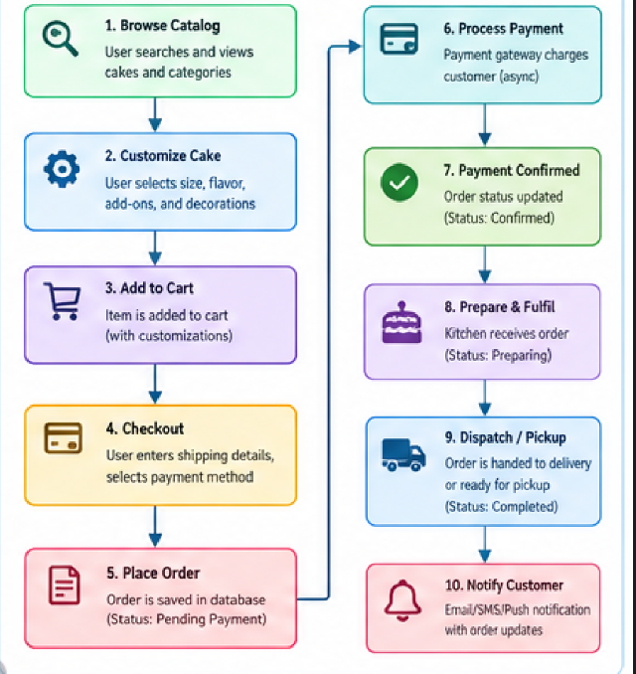

4.2 Payment Flow (Detailed, With Idempotency & Failure Handling)
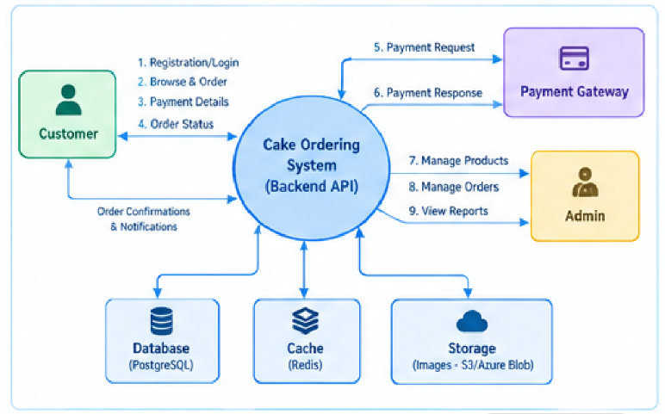

4.3 Data Flow Diagrams
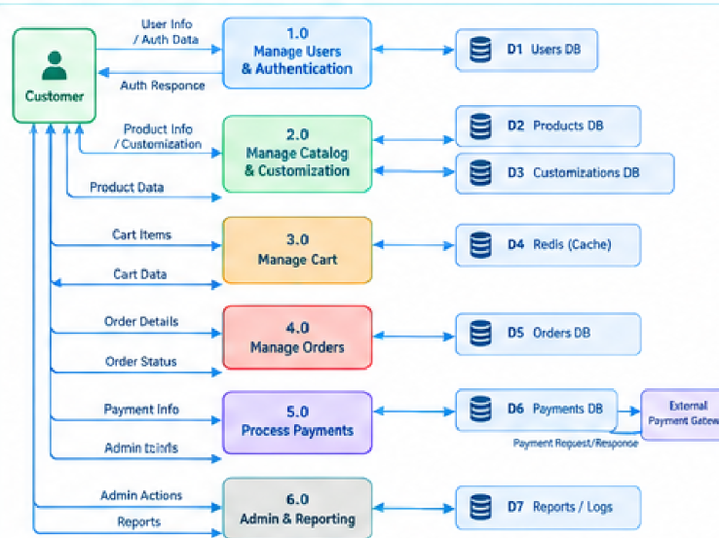

4.4 Authentication Flow (Customer SSO vs Admin Local)

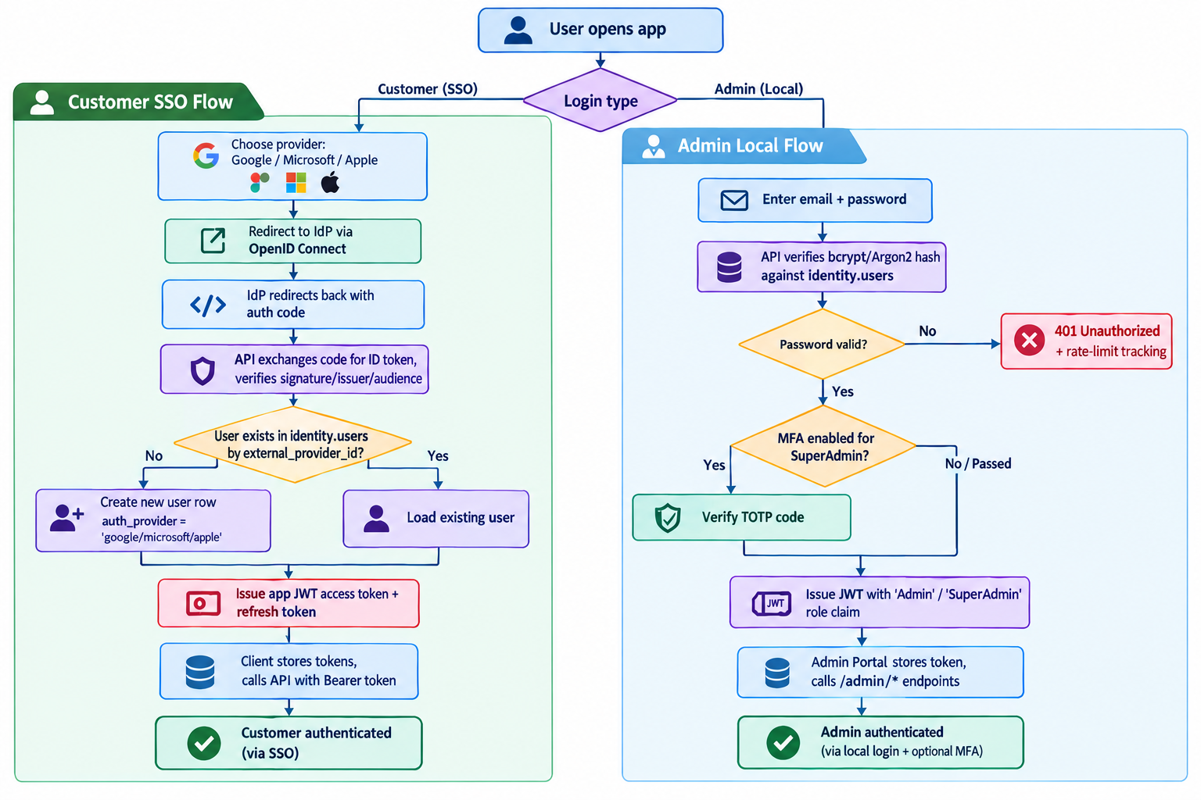

5. API Surface Summary
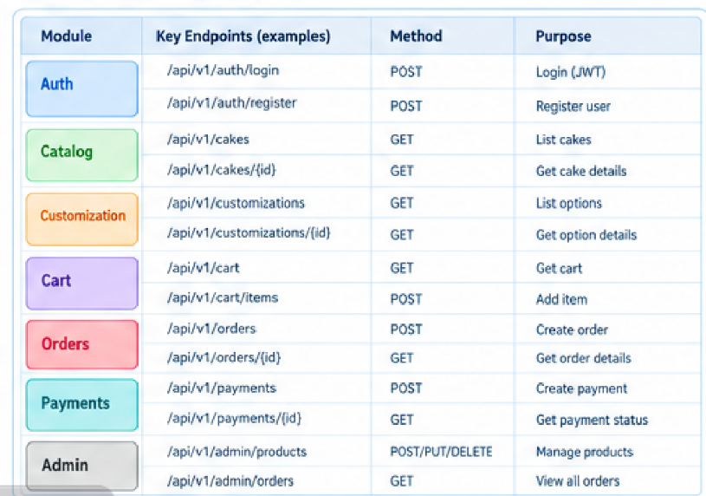

6. Cross-Cutting Concerns
- Authorization model: Policy-based ([RequireRole("Admin","SuperAdmin")] equivalent via .RequireAuthorization("AdminOnly") on Minimal API route groups). SuperAdmin is a strict superset of Admin (e.g., can manage other admins; regular Admins cannot).
- Validation: FluentValidation per-endpoint DTO validation, plus domain-level invariant checks in service layer (e.g., customization rules) — validation is never trusted from the client alone.
- Idempotency: Idempotency-Key header required on POST /orders and payment initiation to prevent duplicate orders/charges on network retry — enforced via the unique idempotency_key column.
- Consistency & reliability: Transactional Outbox pattern ensures order state changes and event publication are atomic — no "payment succeeded but admin never notified" gaps.
- Caching strategy: Catalog and customization schema are cache-through in Redis with short TTL + explicit invalidation on admin writes; cart is Redis-backed for guests, DB-backed (mirrored) for logged-in users.
- Observability: Structured logging (Serilog), distributed tracing (OpenTelemetry), health checks (/health/live, /health/ready) for k8s readiness/liveness probes.
- Security: HTTPS everywhere, JWT with short-lived access tokens + rotating refresh tokens, password hashing via Argon2id, rate limiting on auth endpoints, webhook signature verification, PCI scope minimized by never touching raw card data, secrets in a vault (not appsettings.json), CORS locked to known frontend origins.
- Data protection: Row-level soft delete on cakes/customization_options so historical orders remain valid even after catalog items are retired; PII (addresses, phone numbers) encrypted at rest where the hosting platform supports column/volume-level encryption.
- Scalability: Stateless API layer behind a load balancer; sticky sessions not required since JWT + Redis carry state; Postgres read replicas can be introduced for catalog-heavy read traffic as load grows; SignalR backplane (Redis) required once scaled beyond a single API instance.
- API versioning: URL-based (/api/v1/) from day one to allow non-breaking evolution once the SPA/mobile clients are built against it.

7. Open Decisions / Recommendations for Next Phase
These require business input before implementation begins:
- Payment gateway selection — region matters (Stripe is not fully available in all African markets; PayFast/Paystack/Yoco may be more appropriate depending on target geography).
- Delivery logistics — is delivery in-house (needs driver assignment/tracking) or third-party courier API integration? This affects the orders schema and adds a deliveries module.
- Multi-tenancy — is this single-bakery or a multi-vendor marketplace (multiple bakeries selling through one platform)? Current schema assumes single-vendor; multi-vendor would require a vendors table and cakes.vendor_id.
- MFA scope — recommend enforcing MFA (TOTP) specifically for the two SuperAdmin accounts (Phindile, Lulama) given their elevated privileges over pricing and catalog.
- Image upload pipeline — need to confirm whether admins upload raw images (requiring server-side resize/optimize/CDN pipeline) or provide URLs only.
- Guest checkout — confirm whether guest (non-account) checkout is required, which affects the cart/session design already accounted for above.

End of System Design Document.

